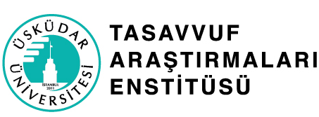

**“Humanity, Sufi Thought and Healing” Lecuture Series**

**Application Form**

*These documents****are not required****for current graduate students or graduates of Üsküdar University.*

Please fill in this application form and send it together with other required documents no later than July 17, 2025 to the following e-mail address: **lectureseries@uskudar.edu.tr**

**Additional Documents**

1. A copy of Turkish National ID and/or relevant pages of passport for applicants from abroad

2. A copy of the payment receipt (Online payments do not require a receipt)

**I. Details of Identification**

Name:

Surname:

Date of Birth:

Address:

Mobile Number:

E-mail:

Emergency contact information:

**II. Education**

High School:

College:

Postgraduate:

“I hereby ceritfy that the information provided in this form is complete, true and correct to the best of my knowledge.”

**Signature:**

**Date:**