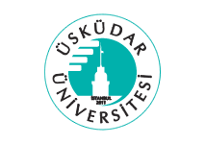
ÜSKÜDAR UNIVERSITY
Faculty of Humanities and Social Sciences

2023-2024 Fall Semester
RCUL 101 University Culture I

Faculty Member Advisor

………………………………..

Plagiarism Statement

I declare that this report is my own work, is not copied from any other person's published or unpublished work, and has not been previously submitted for assessment anywhere.

Student Name
Student ID Number
Student Signature

