Contents
Institute Process Flow Diagram 2
Your Student E-mail 2
Important Mail Addresses 2
Academic Calendar 2
What are the University's Applications STIX, ALMS, and OBS? 3
OBS 3
How do I register for my course at OBS? 3
Which courses will I choose? 3
What should I pay attention to in the course registration? 4
STIX Platform 4
ALMS Platform 5
How will be the Exams? 6
If the faculty member planned the exam in the LMS: 6
If the faculty member planned the exam as homework in the LMS: 7
If the faculty member requested your homework / exam to send over STIX: 8
What if I don't attend the exam? 8
Institute Announcements 8
Forms that may be required during period 8
Problem Situations 9

Institute Process Flow Diagram
You can find the ranking of the work to be done during your teaching process at the Institute at:

https://cdn.uskudar.edu.tr/uploads/files/2019/04/22/fbe-yl.pdf

Your Student E-mail
You must actively use the e-mail address which the university has defined for you, in order to keep up-to-date announcements and to communicate with faculty members.
You can click on the https://portal.office.com link to log in to your e-mail address.
Your email address is like isim.soyisim@st.uskudar.edu.tr and in your password, the first letter of the name must be a capital letter, T.R. ID# or Passport# must be a combination of the number and *. For example, for a student named Busra, the password must be B14807694569*.
If you can't use your email address even though you write it in the form of a first and last name, you can find out your email address by clicking on the link https://bt.uskudar.edu.tr/ogrenci-st-e-mail-adresi-ogrenme
To change your mail password, just click on the link https://teksifre.uskudar.edu.tr.
Just click on the https://uskudar.edu.tr/sobe/akademik-kadro link to access the e-mail addresses of the faculty members.

Important Mail Addresses
Contact Information you can reach the university: +90 (216) 400 22 22- info@uskudar.edu.tr
Assoc. Prof. Mesut KARAHAN (Director)
mesut.karahan@uskudar.edu.tr
Asst. Prof. Nuri BİNGÖL (Asst. Director)
nuri.bingol@uskudar.edu.tr
Hulya DUNDAR Secretary of Institute
hulya.dundar@uskudar.edu.tr
Student affairs: asli.isik@uskudar.edu.tr - ogrenciislerigrup@uskudar.edu.tr
Information Technologies: If you experience any problems with the system //bt.uskudar.edu.tr

Academic Calendar
You can access Uskudar University academic calendar from the following link:
https://uskudar.edu.tr/en/academic-calendar

What are the University's Applications STIX, ALMS, and OBS?
The three must-use applications are OBS, STIX, and ALMS.

OBS
The Student Information System (OBS) is a platform where you can record courses, and add/drop courses, view grades and absence status, and see your curriculum, semester averages, and transcript.
You can reach OBS by clicking on the link https://obs.uskudar.edu.tr/oibs/ogrenci/login.aspx.
Here your automation username is your school number. And your password is, the first letter of your name in capital letter, your TR ID# and at the end the * symbol (A12345678901*).

How do I register for my course at OBS?
Click on the "Course Registration" button on the "Course and Semester Procedures" tab in OBS.
Click on the green plus (+) button on the left side of the courses and select the course from the screen that opens. This process must be done for all courses to be taken.
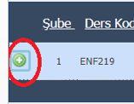
After selecting all your courses, you should press the” check " button.
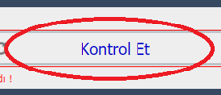
After checking, click the “Confirm” button.
After checking, you confirm your course selection by choosing finalize. By doing this, you send it directly to your consultant for approval. No need to e-mail your consultant again. Your Course Registration will be completed when your consultant has confirmed your lessons.

Which courses will I choose?
You can learn the courses you need to choose by checking your curriculum at https://uskudar.edu.tr/fbe/programlar. Some sample links:

What should I pay attention to in the course registration?
Please pay attention to the weekday or weekend mentioned next to the lessons in the course registration. There is no mixed course selection possible. Select your lessons from the weekend group or on the weekday group. If you choose a mixed course, your courses will not be approved by your advisor.
Take only the courses you need to take in the curriculum during the semester. If you take extra lessons, your courses will not be approved by your advisor.

STIX Platform
STIX is a platform where announcements are made in all master's programs, you will communicate with the faculty member, and course notes are shared.
You can reach STIX by clicking on the link https://stix.uskudar.edu.tr/login. Here you need to log in with your e-mail address and mail password.
To use STIX, you must complete your course registration via OBS. The courses you take after completing your course registration are defined in STIX. Here you can see the lessons you have learned when you click on the lessons tab.
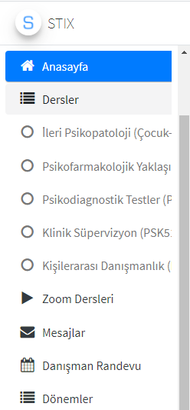

In the courses tab at STIX, academicians can share course-related materials, presentations, enriching readings and suggestions. In addition, they can use this place to make any announcements or related to the exams as well. For this reason, you should actively follow the courses tab in your STIX.

You can also text academics at STIX. The faculty member can also text you. For this reason, you should actively follow your STIX message box.
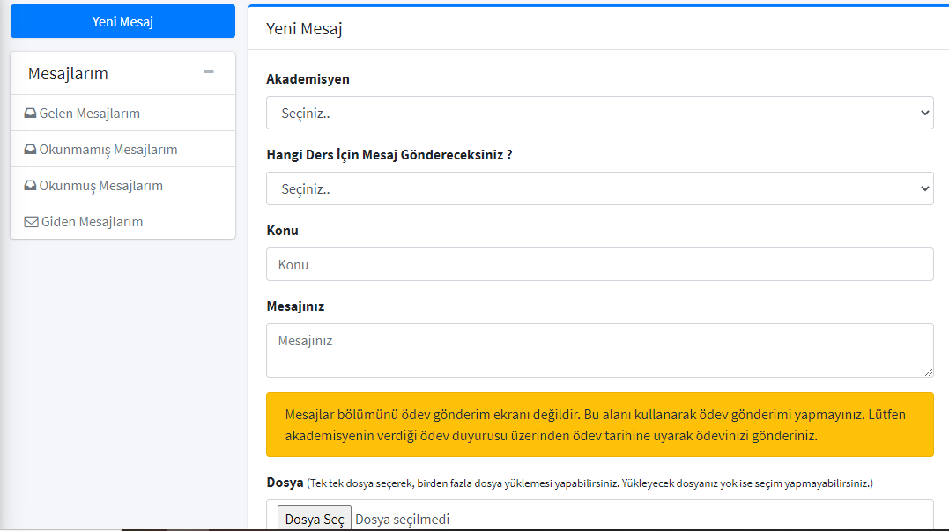

ALMS Platform
You can reach the LMS system by clicking on the https://lms.uskudar.edu.tr/ link. You can enter the system with your OBS username (student number) and password information.
Sections available on the user's home page are; Top Menu, left menu, “My surveys”, “My upcoming activities”, “My deadlines”, “My lessons”, “Announcements”, and “What's going on?”.
To use LMS, you must complete your course registration through OBS. After completing your course registration, the courses you receive are defined to STIX. Here you can see the lessons you have received when clicking on the Lessons tab.
When you log in to LMS, you can see live classroom plans, course name, day, and start time details about your courses under the topic "My Activities That Will Start Soon" on the home screen.
In LMS, you can access your course list from the "My Courses" menu and select which course will start live. Live lessons that begin will appear as "Started". When you click on it, you can log in to your live lessons.
After entering the course, the instructor of the course cannot hear the students unless the student activates the microphone feature. During the live lesson, students will see the participants in the "Participants" section on the right side of the screen and ask their questions about the course in the "Chat" section.
The processed course auto-registers at the end of the course and you can watch it again at any time.

How will be the Exams?
How to make the exam can be shared with the students in advance by the academician who teaches the course and the exams can be done in the form of homework or online exams. Online exam questions can also be given in the form of multiple-choice or open-ended exam questions.

If the faculty member planned the exam in the LMS:
First of all, please do not enter the exam via a mobile device in order to avoid ruptures during the online exam. Log in to the test via computer and with the GOOGLE CHROME browser.
Exams must be taken from the RED colored exam entry button on the LMS homepage. Clearing cookies from the GOOGLE CHROME browser just before starting the exam with the clear history option will make it easier to enter the exam and the LMS system (If the LMS system cannot be accessed, cookies must be cleaned and the input must be retried).

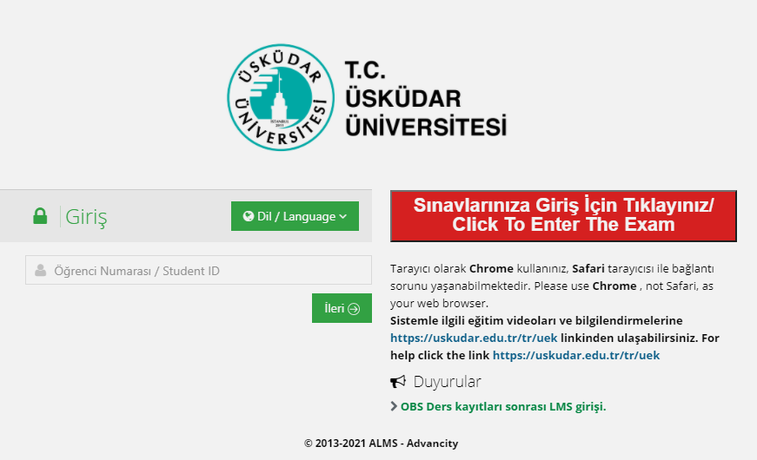

When you log in, your defined exams are included in the 'Completed Exams' section and the exams you have completed in the 'Active Exam List' section are included in the 'Completed Exams' section. In order to ensure access to the exam, you must wait for the examination time defined by the faculty member.
At the exam begin, you will meet the faculty member's exam START message. After you confirm this message, your exam and the exam period will begin.
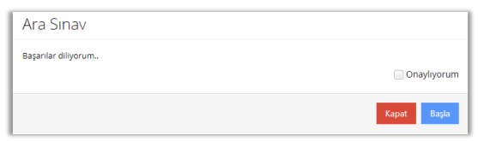

As soon as the exam starts, your time counter works. You can see on the exam screen, how many questions you have, which ones you have answered, which ones you have left unanswered, which questions you have not been able to save.
In the background of each student's question field, there is a hologram with the student number written. Therefore, students who attempt to crib during the exam and take photos of the questions can be identified.
When you finish the exam, you will see the faculty member's end of exam message. If desired by the faculty member, your points can be published through the LMS before the OBS as well.
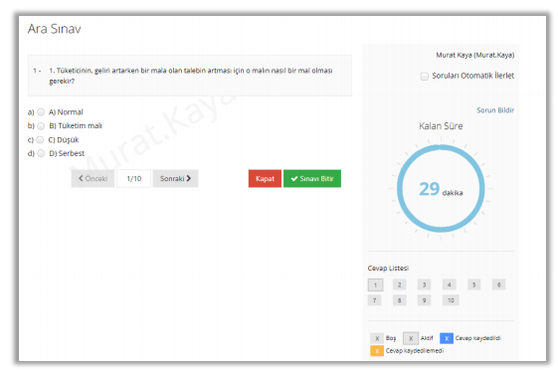

If the faculty member planned the exam as homework in the LMS:
The only activity with a deadline is the homework. If you pass the time, you will not be able to upload your homework. With the Download button, you can download the homework file uploaded by the faculty member to your device. With the Upload the homework button, you can forward your own homework file to the faculty member. From the allowance to upload section, you can see how many times you have the right to upload files for this homework. Usually, once a time of uploading right is defined. Therefore, just upload your file once you are sure of your homework.
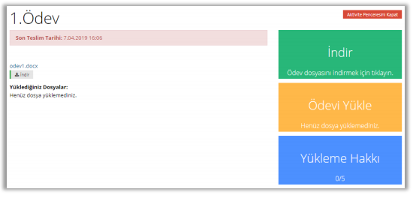

If the faculty member requested your homework / exam to send over STIX:
Go to the homework announcement on the courses tab in STIX, which the faculty member has identified. The only activity with a deadline is the homework. If you pass the time, you will not be able to upload your homework. With the Upload the homework button, you can forward your own homework file to the faculty member. From the allowance to upload section, you can see how many times you have the right to upload files for this homework. Usually, once a time of uploading right is defined. Therefore, just upload your file once you are sure of your homework.

What if I don't attend the exam?
For our students who cannot take the exam for reasonable excuses or who had technical problems during the exam, there will be held a "Compensation Exam" within the framework of the existing legislations by the Decision of the Board of Directors of the relevant academic unit. If you have a problem, send an e-mail to the faculty member explaining the situation from your Uskudar e-mail address.

Institute Announcements
Announcements made by the Institute are delivered to you by your student e-mail address or by the https://uskudar.edu.tr/fbe/en web page. Please check these areas frequently.
In addition to this, faculty members or heads of departments often reach you via STIX by message or announcement.

Forms that may be required during period
You can find various forms that may be required during the period collectively on a page, and you can use them by downloading them from this page as needed: https://uskudar.edu.tr/fbe/en/forms

Problem Situations
In the case of problems, first, ask by email the course's faculty member, then the head of the department or the secretariat of the Institute for help, according to the subject. If the problem has not been solved, you can reach the Institute Manager and Deputy Manager by e-mail.

